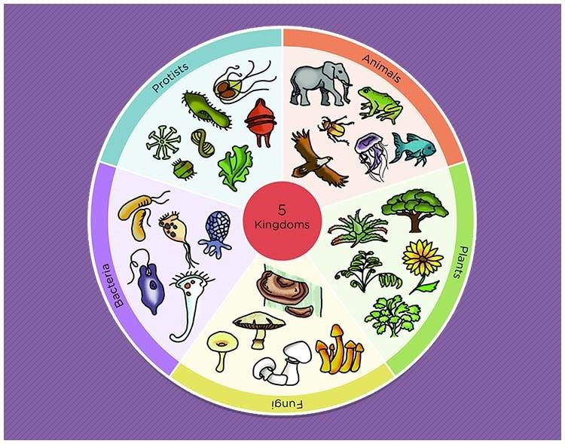

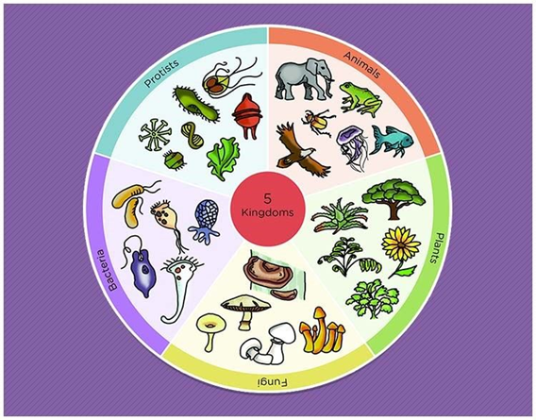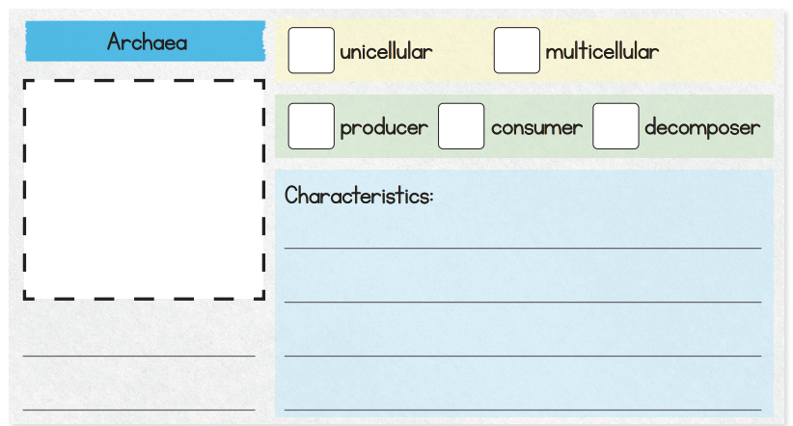

**The five kingdoms of life**

**Bacteria**

